**Design Review #2**

Josh Grinberg

Mindy Huang

Chris Ling

Pedro Milani

Team 8

**Overall Design**

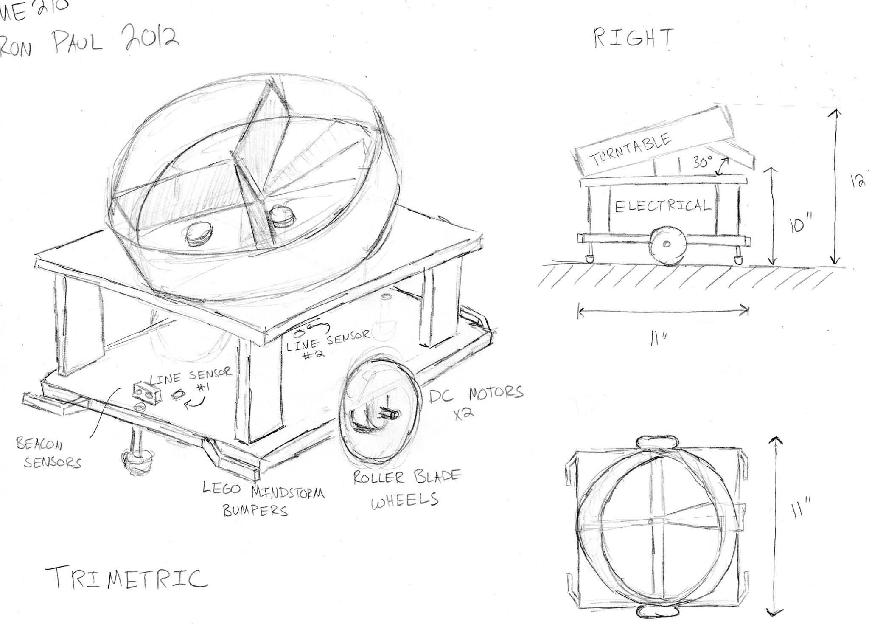

**Coin Collecting/Dispensing**

*Idea 1*

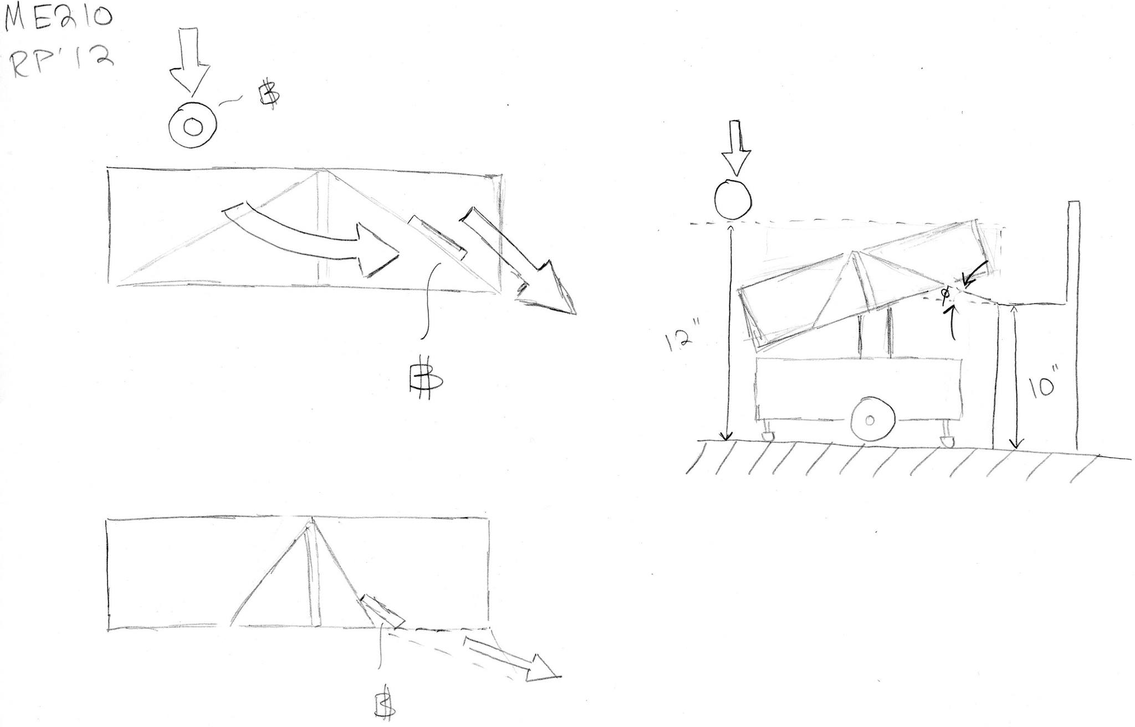

*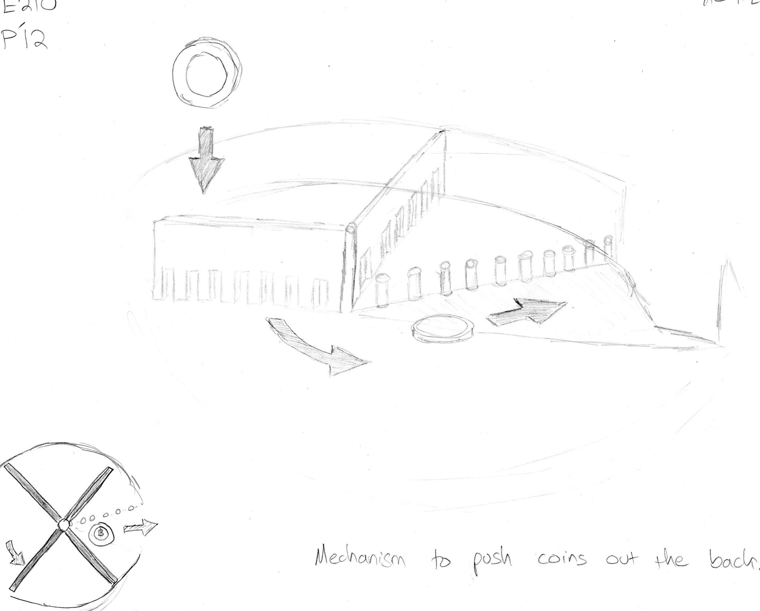Idea 2*

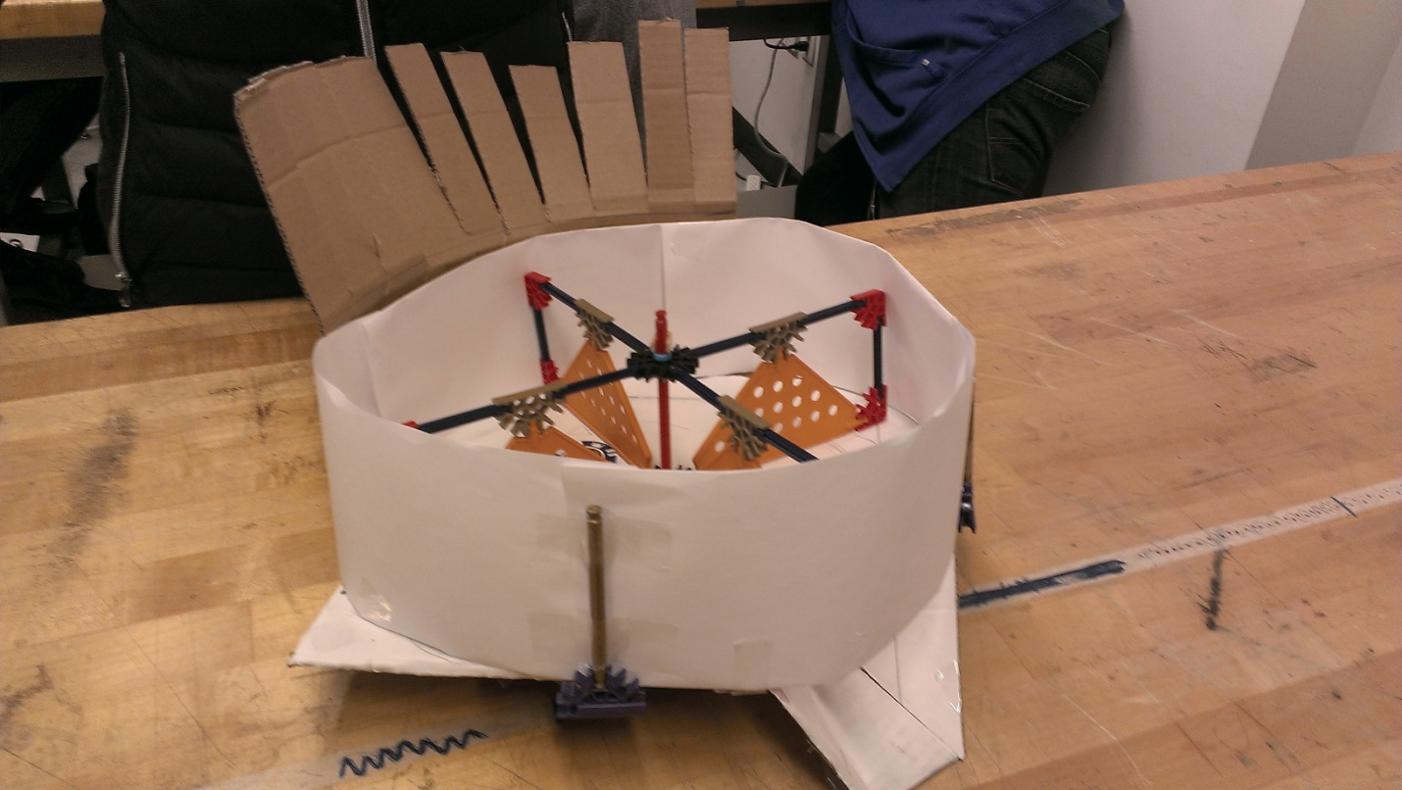

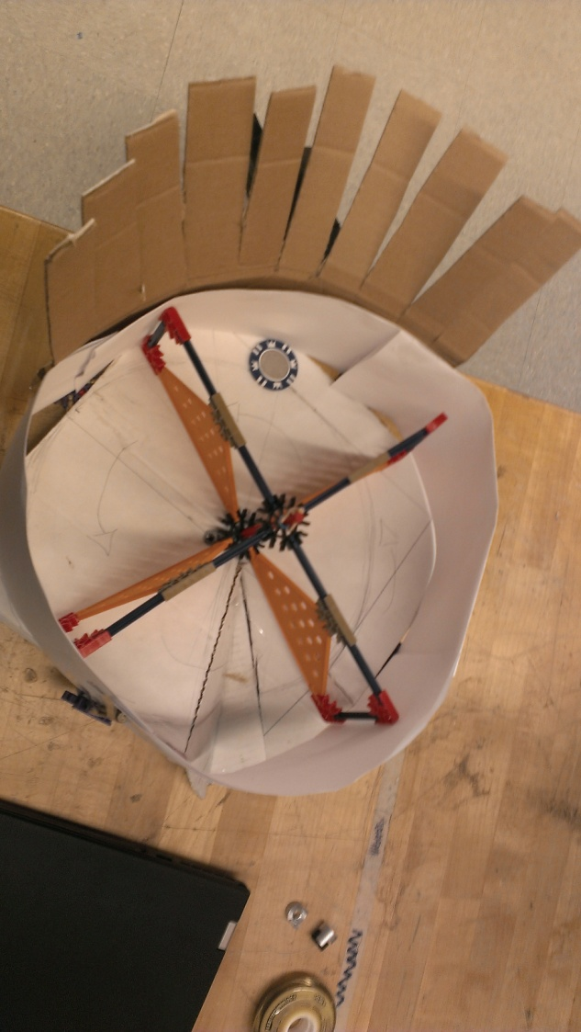

**Line sensing**

We’ll use 2 of them in a line. One in the center of the robot and one at the front end.

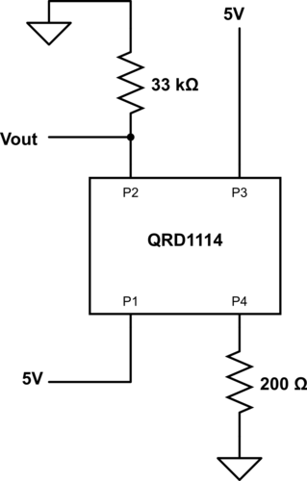

Testing data for value read by the Arduino vs. distance from the floor. 'T' stands for the sensor with tape on it, and 'NT' stands for the sensor without tape on it. (Tape used for marking the sensors)

|  |  |  |
| --- | --- | --- |
|  | **White surface** | **Black surface** |
| **2cm** | T    ~39 | T    ~7 |
|  | NT ~25 | NT ~5 |
| **1.5cm** | T    ~111 | T   ~20 |
|  | NT  ~66 | NT  ~11 |
| **1cm** | T    ~590 | T   ~120 +- 10 |
|  | NT  ~410 | NT  ~100 +- 10 |
| **0.5cm** | T    ~990 | T    ~350 |
|  | NT  ~980 | NT  ~300 |

**Pins**

Analog Pins

0 - light1   
1 - light2

2 - beacon1

3 - beacon2

4 -

5 -

6 -

Digital Pins

2 - Motor1_direction

3~ - Motor1_enable

4 - Motor2_direction

5~ - Motor2_enable

6~ - dispensor servo

7 - Servo

8 - bumper1

9~ - bumper2

10~ - bumper3

11~ - bumper4

12 - button presser motor

**Strategy – Beat the Brick**

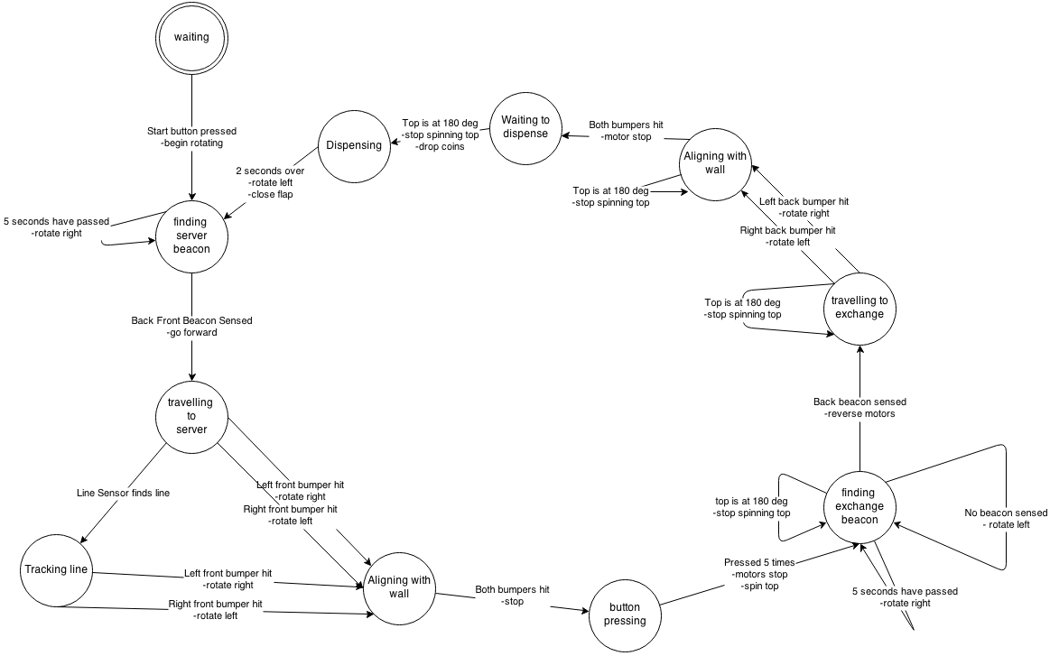

**Drivetrain**

* We will choose a motor out of the 3 that the TAs have available: the Jameco 153438, Jameco 161382, and Jameco 164786.
* The datasheets are not very useful. So, we performed some tests. We know all motors should be driven at about 12V, and we will use and H-bridge (the SN754410 chip) to drive them.
* First, we want the stall current. It must be less than 1A at 12V. To measure this, we applied a DC voltage across the motor and put it in series with a known resistance (R = 47 ohms). The voltage drop across the resistance gives the current, and the voltage drop across the motor (since we know the current) gives the internal resistance of the motor, Rm.
* We got the following values, with tolerances of +/- 20%:
  + 161382: Rm = 9 ohms
  + 153438: Rm = 75 ohms
  + 164786: Rm = 28 ohms
* Note that, when the motors are stalled at 12V, the current is I = 12/Rm. So, the 161382 motor would draw more than 1A of current. Thus, we eliminate it from our choices.
* Next, we look at speed. The smaller motor, the 153438, has a very high gear ratio. So, its torque is very big, but its maximum rotational speed (no-load) is 16rpm. Using the biggest wheels available, of D=8cm, the robot's top speed would be about 2 inches/second. This means that it would take about 20 seconds to get across the field! This is too much; therefore, we eliminate this option.
* Since it is the only remaining option, we choose the 164786. Note that its gear ratio is small, so we will not be able to get a lot of torque. This means we should go for small wheels and a light car.
* We will use an H-bridge to drive the motors, because we need them to go both directions. Due to our familiarity based on lab 3 and the constraint of 1A of current, we will use the chip SN754410.
* We just need to worry about the saturation voltage in the H-bridge. According to datasheet specs, the maximum value for it is 3.8V, under high current. In typical, low current applications, our voltage drop was measured to be consistently around 1.4V.
* We will use both batteries to drive the motor (only one battery, with the H-bridge, would provide a low voltage drop). So, we would have a nominal supplied voltage of 14.4V. That, combined with PWM, should be enough to give a good range of speeds.

